Dear Readers,

I began my revision process by analyzing Dr. Parton’s comments on my D2. I quickly noticed a theme where I expected the reader to piece together many ideas without fully explaining the connection and expounding upon the scholarly works I was invoking and their relation to my chosen community, Bushwick. Furthermore, I also observed that my scope was flawed as I relied on truisms and assumptions about Bushwick as a minority community rather than the data trends I observed. By shifting my scope to that of a broader analysis of gentrifying communities, I could dive deeper into broadscale data trends, and, as a result, I believe that I could turn both of these issues with my draft into the revision’s greatest strengths.

Once I understood the flaws with my draft’s scope and shifted to the broadscale analysis as suggested by Dr. Parton, I spent a lot of time performing analysis and dissection of the data, guided by the theorization that I had performed in my draft process, in conferences, and personal office hours with Dr. Parton. In this process, I found startling trends within the data that I began to turn into a flowchart. It was in this process of reorganization and consolidation of the data and theorizing that I was able to form my current thesis: By looking at New York City’s extensive 311 and criminal summons data following the implementation of Operation Silent Night and the Noise Code overhaul, we can see that the delegation dynamic (i.e., the paradox of control) not only is ineffective at noise abatement but is also linked to selective noise enforcement and criminalization in gentrifying neighborhoods. This is important because these subjective, disproportionate enforcements are capable of altering—and potentially already have altered—the sonic environmentof gentrifying neighborhoods.

Furthermore, my motive has become substantially more multi-layered in this revision. Throughout the majority of the paper, I used contradictions and startling trends within the data to motivate an analysis of how NYC’s authoritative structures, the NYC Noise Code and 311 Helpline, are enabling selective enforcement and criminalization. The data analysis now also has a motive established behind it as I point back to the data's implications on the communities they represent. This point is especially climaxed and turned into my “so what” in the later portions of my paper. This was a stark transition from my D2, which failed to link the data (my textual motive) clearly to my scholarly sources.

My evidence and analysis have become more substantial and interwoven within the paper. The quantity of evidence, backed in the 311 and Summons analysis, has grown significantly, but I believe that my clearer organizational structure, facilitated by my outlining and my presentation of the data where the evidence is the "so what" of the prior analysis, prevents me from falling into the ‘dead fish’ essay structure while striking the balance of minimizing redundancy and maximizing clarity to the reader. Furthermore, I believe the analysis is much more rooted in what the data is able to show, being careful not to ascribe causality but rather to describe the trends observed and the implications of those trends.

Moreover, my structure and orienting have seen significant improvements since the draft. My draft spent the first third of the paper orienting the reader on various topics without making it quickly clear why they should be important to the reader. In this revision, I split my orienting into contextual-based orientation at the beginning with a broad overview of key terms and theories (i.e., paradox of control). However, I now perform small bits of orienting later in the essay, such as the introduction of Martin, which prevents the reader from being overburdened with information at the beginning of the paper and makes each individual section of the paper much more cohesive, where the context, data, and theorization are grouped together. This lent itself to the changes in my structure, where I prioritized a context/data — problem — response / theorization structure throughout the essay. Overall, these changes made the essay transition into a more cohesive and readable piece. Furthermore, these structural and orientation changes and their incredible impacts on improving the paper's quality have opened my eyes to the power of good structure, which can be assisted through a definitive and thorough outline.

Overall, I am very excited with the data that I was able to find in the paper (if not alarmed), and I believe that the paper captures this very well, wrapping in many of the concepts (both sound-related and with regards to writing style) that we have talked about in class. I want to take this paper further and continue exploring what it means for gentrification, perhaps through the R3 or as an independent research project. I would greatly appreciate any feedback that you have!

Regards,

Jack Prewitt

Minorities, 14,354. Whites, Zero: New York’s Sonic War in Gentrifying Neighborhoods

Jack Prewitt

WRI 189: Sound and the City

Dr. Christopher Parton

March 29, 2024

*This paper represents my own work in accordance with University regulations*

*/s/ Jack Prewitt*

**Minorities, 14,354. Whites, Zero: New York’s Sonic War in Gentrifying Neighborhoods**

Anthony Rosado, in his adolescent recollection of Bushwick—a Brooklyn, New York City neighborhood—recounts “neighbors listening to music, calling out to their family members through the windows,” which clashes with his newly observed “growing sense of ‘white normalcy’ that silenced the sounds he grew up with in the neighborhood.”[1] Rosado and many other long-term Bushwick residents paint a pre-gentrification picture of freedom of expression, culture, life, and sound in their descriptions of the neighborhood to Cynthia Tobar, which she records in *Cities for People, Not for Profit: Gentrification and Housing Activism in Bushwick*. Bushwick and other gentrifying regions of New York City like Crown Heights, Harlem, SoHo, and Chinatown have experienced rapid demographic transition, with minority communities being supplanted by white individuals.[2]

As these neighborhoods transformed in the early 21st century, New York City’s authoritative attitudes towards sound underwent a stark change, particularly in these gentrifying communities. Beginning in 2002, then-Mayor Michael Bloomberg announced Operation Silent Night, a NYPD initiative to increase noise enforcement in selected high-noise neighborhoods.[3] According to Lilian Radovac in *The ‘War on Noise’: Sound and Space in La Guardia's New York*, the operation targeted “newly gentrified districts” and served to ultimately constrain “aural and spatial practices” of these regions, which Rosado himself has observed with the dwindling frequency of cultural celebration and music in the neighborhood.[4],[5]

The Bloomberg administration then overhauled the NYC Noise Code in 2005, which enhanced Silent Night’s expansion of authoritative enforcement. The new codification sheltered enforcement of *institutional sounds* (i.e., sounds associated with the development and maintenance of the city, like air compressors, sanitation trucks, construction work, and construction containers/material) behind objective dB(A) metrics unverifiable by the general public while expanding *interpersonal sounds* (i.e., sounds associated with people like parties, music, personal audio devices, lawn care, and animals) to ‘plainly audible sound’—defined as any sound audible from a given distance from a source, typically 25 feet.[6] By invoking subjective definitions of interpersonal sound and objective metrics for institutional sounds, the Noise Code embodies the *paradox of control* outlined by Karin Bijsterveld in *Listening to Technology in Mechanical Sound Technology Culture*, where governments delegate non-quantifiable noise issues to the purview of the people while limiting quantifiable matters, like construction and airplane noises, solely to government enforcement.[7] As a result, citizens are “responsible for dealing with the most slippery forms of noise abatement and distanced from the most tangible ones,” a dynamic that ultimatelyemboldened Bloomberg’s Silent Night’s proclivities and, according to a similar discussion by Radovac, assisted the operation in marshaling “the considerable resources of the city of New York to intervene in aural conflicts on behalf of the city’s most privileged residents.”[8]

Bijsterveld posits that the disparity in delegation found within the paradox of control has hindered the ability of governments to “wipe noise from the public agenda.”[9] However, an analysis of New York City’s extensive 311 and criminal summons data following the implementation of Operation Silent Night and the Noise Code overhaul suggests that this delegation dynamic (i.e., the paradox of control) not only is ineffective at noise abatement but is also linked to selective noise enforcement and criminalization in gentrifying neighborhoods. These subjective, disproportionate enforcements are then capable of altering—and potentially already have altered—the sonic environmentof gentrifying neighborhoods.

From Operation Silent Night’s inception on October 10, 2002 to June 8, 2004, the New York Police Department (NYPD) issued 3,706 Criminal Court summonses citing noise.[10] However, the lack of a robust noise code appears to have complicated enforcement, as 33,996 non-noise-related summonses were cited to those initially stopped for noise violations, resulting in Mayor Bloomberg calling Silent Night a “Band-Aid to a serious problem.”[11] Recognizing the shortcomings of the initial Silent Night operation, the Bloomberg administration pushed for a new codification of the NYC Noise Code that was ultimately more successful at increasing noise-specific criminalization, as quantified by a notable uptick in criminal court summons. Following the installation of the Noise Code in 2005, criminal court summons for noise rose to their maximum, peaking at 20,383 criminal summons in 2007 (Figure 1), and remained relatively high for the duration of the Bloomberg mayorship, which ended in 2013.[12] Thus, the overhaul of the Noise Code expanded the ability of the NYPD and Department of Environmental Protection (DEP) to enforce noise violations in a targeted manner without the necessity to ascribe other violations to noise violators in attempts to combat sound.

**Figure 1:** *Quantity of Noise-Related Criminal Summons by Year from 2006–2023[13]*

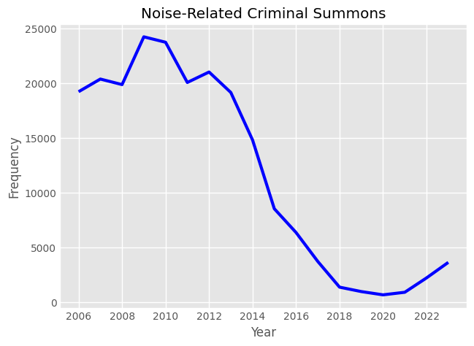

However, further analysis of the Noise Code statutes invoked in criminal court summonses from 2006–2023 reveals a more complicated picture of this increase, with interpersonal sounds being far more criminalized than institutional ones. In Table 1, “General Prohibitions,” “Unreasonable Noise,” and “Motor Vehicles” are derived from common instances of interpersonal sounds, whereas “circulation devices” (e.g., air conditioning and pumps) is the only institutional sound within the top 9 most common citations. Furthermore, construction-centric sound ordinances (i.e., Noise Code sections 24–222 through 24–230) were only cited in 230 out of 210,999 total summonses between 2006 and 2023.[14] As such, it appears that the paradox of control’s delegation of institutional sound enforcement to authoritative bodies in the NYC Noise Code has resulted in the relaxed enforcement of institutional sounds compared to their interpersonal counterparts. In gentrifying communities, where construction is generally ubiquitous, this relaxed enforcement of noise-code violations can thus enable redevelopment to continue with minimal hindrance.

**Table 1:** *Top 5 Sound Law Sections invoked in NYC Criminal Court Summons from 2006–2023[15]*

| **Law Section** | **Section Title** | **Number of Summons** |
| --- | --- | --- |
| 24-218 | General Prohibitions | 75,399 |
| 240.20-2 | Unreasonable Noise — Disorderly Conduct | 67,828 |
| 24-227 | Circulation Devices | 45,606 |
| 24-220 | Noise Mitigation Plan | 9,329 |
| 24-236(A) | Motor Vehicles | 2,887 |

With interpersonal sounds garnering higher enforcement rates following the Noise Code codification, the patterns of their criminalization are critical in conceptualizing how New York's authoritative attitudes toward sound have shifted. The ordinances related to interpersonal sounds have been altered to include more subjective regulations needed to identify and cite the sound (e.g., only needing to observe the sound from 25 feet away to cite ‘plainly audible sound’).[16] This allows the NYC Noise Code to enable a selective enforcement of noise as the NYPD and DEP can disregard objective measurements of institutional sounds with minimal scrutiny as they are the only bodies authorized to invoke measurement sound levels while also utilizing the murky enforcement definitions of interpersonal sound to invoke criminalization based on the enforcement officer’s conception of ‘plainly audible sound’ and ‘unreasonable noise.’ Furthermore, the data suggests that this conception is, in fact, rooted in ideas of race and neighborhood status: there is an increase in criminalization of interpersonal sounds in gentrifying districts (Figure 2**)** as well as an increase in summons given to minorities as 91.79% of the summons with the race reported were of a minority race (See Table 2).[17]

**Table 2*:*** *Race of Noise Code Violators Receiving Criminal Summons[18]*

| **Race** | **Quantity of Summons** | **Percentage of Total** |
| --- | --- | --- |
| Black | 5,655 | 35.90% |
| White / Hispanic | 4,429 | 28.12% |
| Black / Hispanic | 2,360 | 14.98% |
| Asian / Pacific Islander | 1,859 | 11.80% |
| White | 1,293 | 8.21% |
| American Indian | 127 | 0.81% |
| Hispanic | 30 | 0.19% |

**Figure 2:** *Quantity of Criminal Summons by Neighborhood from 2006–2023[19]*

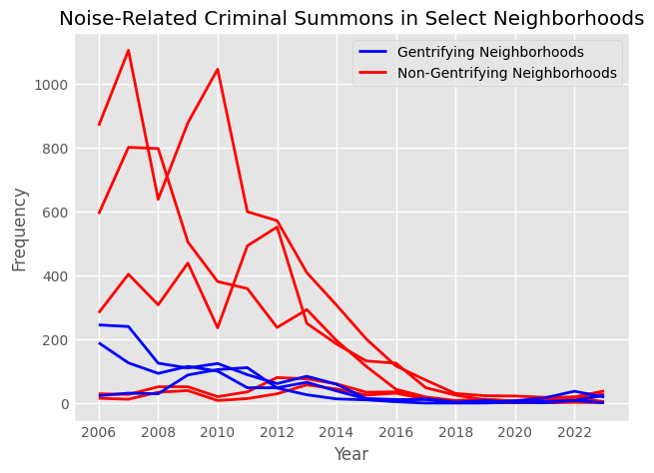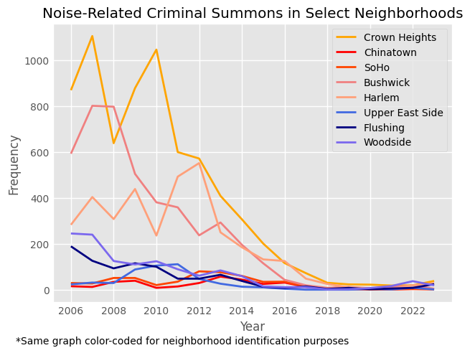

This strong racial trend and disparity in sound enforcement was also observed by Alison Martin in Washington, D.C., which she writes about in *Plainly Audible: Listening Intersectionally to the Amplified Noise Act in Washington, DC*.[20] In this piece, she asserts that the process of gentrification is rooted in a “transformation of residential and commercial spaces that are deeply rooted in racialized and classed ideas of desirability, development, and progress.”[21] The subjectivity and social conditioning of noise thus present a battleground for ideas of desirability through the sonic realm. With the rise in ethnic heterogeneity in gentrifying areas,[22]elevated periods of dissonance in the soundscape are invoked where each demographic's sonic biases and social conditionings clash with one another, instituting the transformation of the neighborhood toward the desired development of the imposing group. The NYPD’s disproportionate enforcement of noise violations towards minorities (Table 2) and gentrifying areas (Figure 2) suggests that noise code enforcement favors a white-skewed racialized idea of desirability.

With apparent racial skews in enforcement and Martin's considerations of gentrifying transformations that are "always sonic, as they reshape the preferred sonic practices of a space, and maintain desired soundscapes through various tools of discipline, criminalization, and citizenship,” an evaluation of the dynamics of discipline, criminalization, and citizenship in gentrifying communities is imperative to understanding how these tools reshape the soundscape of the neighborhood.[23]While criminalization of the soundscape can be exclusively observed through the Criminal Summons data, the discipline and citizenship of Martin’s proposal are more challenging to observe. However, the NYC 311 line—a helpline to report non-emergency concerns such as noise complaints—can provide a lens into how both gentrifiers and long-standing residents employ their citizenship within the soundscape (i.e., participating in the 311 line) to discipline incidents of sound they do not deem desirable (i.e., invoke police presence). An analysis of 311 noise complaints per capita from gentrifying neighborhoods (Harlem, Bushwick, Crown Heights, Chinatown, and SoHo) as well as those not reporting imminent threats of gentrification in their Community District Reports (Woodside, Jackson, Upper East Side, Flushing) reveal stark, continual increases in NYC noise complaints.[24] This indicates that the changes to the Noise Code followed Bijisterveld’s hypothesis that the paradox of control “has not helped to wipe noise from the public agenda.”[25] However, within these communities,Figure 3 illustrates a distinct pattern in which gentrifying neighborhoods (denoted in red tones) have nearly 200% more noise complaints per capita than ungentrified neighborhoods (denoted in blue tones), suggesting that the paradox of control is exacerbated within gentrifying communities and worthy of further investigation.[26],[27]

**Figure 3:** *311 Noise Complaints Per Capita in various New York Neighborhoods[28]*

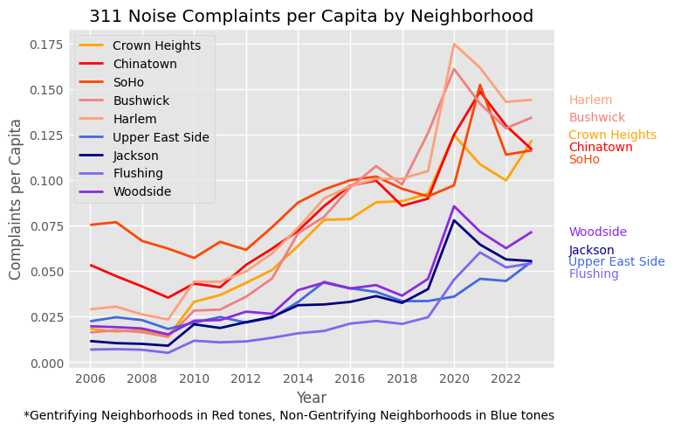

The rapid rate of growth of 311 noise complaints in gentrifying neighborhoods relative to non-gentrified neighborhoods deviates from Huan Tong and Jian Kang’s analysis in *Relationship Between Urban Development Patterns and Noise Complaints in England,* where it is theorized that dense, contiguously built, centralized neighborhoods with many transportation networks would display typically increased noise complaints.[29] However, the structural urban development of each of the gentrifying neighborhoods in this analysis was remarkably similar and unchanging from 2006–2023.[30] Interestingly, the increased rates of change in 311 noise complaints per capita—a shift in the citizenship sentiments towards the soundscape—in these gentrifying neighborhoods coincide with the rapid demographic transition towards ethnic heterogeneity in their respective gentrifying processes.[31] The simultaneous occurrence of both phenomena while controlling for urban development highlights demographic transition as a primary driver behind the increase in 311 noise complaints. This trend extends Martin’s theory of citizenship as the increase in sonic conflict coinciding with the increase in heterogeneity (which facilitates interactions between different racial and social groups) suggests that citizenship is not only used to “reshape the preferred sonic practices of a space” but is also galvanized by the structural elements of gentrification, creating an enhancement of citizenship in gentrifying neighborhoods.[32]

This provoked increase in citizenship amid gentrification, manifesting as 311 reports, provides extensive information to law enforcement bodies about potential violations on which they can enact discipline. Despite 311's logging all categories of noise complaints, discipline trends reveal an apparent discrepancy in the timeliness of response time to certain complaints: across 6,198,445 311 reports, interpersonal complaints averaged approximately 3 hour response times, and institutional complaints, over 42 hours (Table 3).[33] By disciplining interpersonal complaints expeditiously, gentrifying areas are disproportionately impacted as these complaints interact at greater frequencies in these neighborhoods due to an increase in the clashing of racialized conceptions of noise, as suggested by Martin’s theorization in Washington, D.C. With the invoked police presence, this increased discipline thus lends itself to increased enforcement, which has been previously observed to lean towards minority demographics. Furthermore, the delayed response times to institutional noise complaints and the aforementioned decrease in enforcement of institutional matters suggest a discrepancy in discipline that disproportionately hinders minority sonic freedoms while enabling primarily white-focused gentrification redevelopment to continue.

**Table 3:** *Noise Complaints and Average Response Times[34]*

|  |  |  |  |  |
| --- | --- | --- | --- | --- |
| **Interpersonal Complaint** | **Average Response Time** |  | **Institutional Complaint** | **Average Response Time** |
| Loud Music/Party | 3 hours, 3 minutes |  | Jack Hammering | 1 day, 19 hours |
| Loud Talking | 2 hours, 57 minutes |  | Construction Before/After Hours | 1 day, 15 hours |
| Banging / Pounding | 2 hours, 53 minutes |  | Construction Equipment | 1 day, 22 hours |
| Car/Truck Horn | 2 hours, 12 minutes |  | Manufacturing Noise | 1 day, 17 hours |
| Car/Truck Music | 3 hours, 14 minutes |  | Ventilation Equipment, Commercial | 2 days, 6 hours |

This observation of increased citizenship yet selective execution of discipline and enforcement extends the impacts of Bijisterveld’s paradox of control in gentrifying communities as it may, in fact, be conducive to gentrification in the sonic space. The paradox of control within the NYC Noise Code enables easily accessible regulation for individuals to enact citizenship in the soundspace and report sound complaints to the 311 line. This delegation of the identification of sound violations to citizens and away from governmental agencies thus provides a comprehensive picture of all noise violations. Utilizing the expansive data available in gentrifying communities, enabled by the increased citizenship in these communities, law enforcement has the power to discipline those neighborhoods at higher rates and selectively choose complaints rooted in interpersonal sound. The NYPD and DEP can then criminalize select complaints using the Noise Code’s murky definitions when defining instances of interpersonal sounds. With the data illustrating that this enforcement predominately targets minorities and gentrifying communities, the aforementioned process rooted in the NYC authoritative structures of the 311 line and NYC Noise Code can invoke a selective criminalization with respect to noise, targeting minority communities in gentrifying neighborhoods. Thus, the paradox of control established by the authoritative structures of the NYC Noise Code and 311 helpline stoke increased citizenship in gentrifying communities, which corroborates with subjective discipline and racialized enforcement by the NYPD and DEP to provide a framework through which gentrifying neighborhoods can be targeted

In fact, Bloomberg’s alterations of the NYC authoritative structures not only constructed this framework, it appears to have *employed* it. In the gentrifying communities studied throughout this paper, criminal court summons were primarily given to those from minority communities (Figure 4). In fact, from 2006–2015—the era of most rapid gentrification for many of these communities—of criminal court summons with race noted, zero were cited to a white individual. *Zero*. Minorities? *14,354.[35]*

**Figure 4:** *Criminal Court Summons by Race in Gentrifying Neighborhoods[36]*

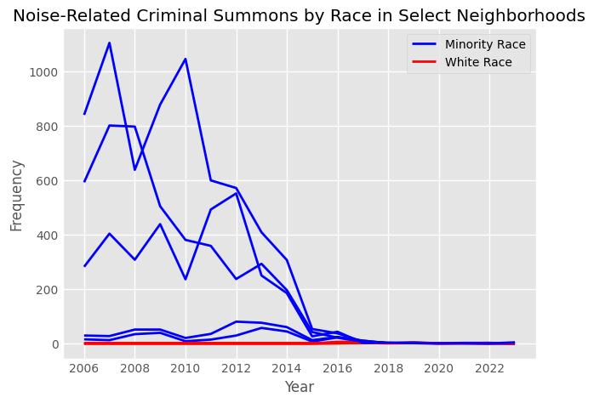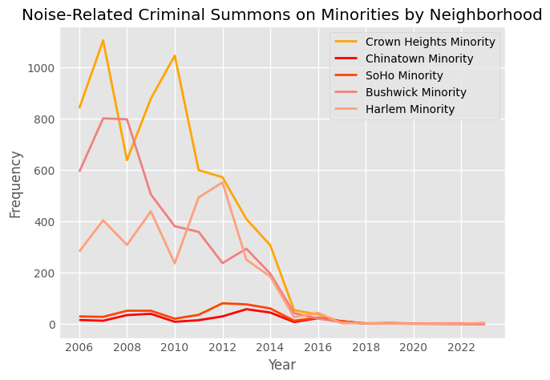

This discrepancy is *unjust*, *unsettling*, and *unacceptable*. With sound being inseparable from culture, these disparities in enforcement and criminalization imply a clear message to the minority groups of gentrifying neighborhoods: adopt the culture and sounds of the dominant White culture or be disciplined and criminalized. While white culture is valuable and worth preserving, its sonic prioritization in gentrifying communities by NYC’s authoritative structures creates a tension between its establishment and the coexistence of the contrasting sounds of minority cultures. With enforcement resulting in fines up to $4,200, the very potential of discipline for noise violations can be enough to alter cultural dynamics with regard to sound, particularly for lower-income minorities.[37] As a result, the structure's enabling of disproportionate criminalization precipitates a stifling of the minority sounds in order to minimize conflict and thus enforcement, gradually leading to minority cultural decline as their sounds diminish. In Bushwick, for example, Rosado’s apt dichotomization of the rife LatinX culture that defined his childhood with the newly established white normalcy reflects this.[38] Should these trends of selective criminalization and enforcement and the authoritative structures that enable them not be acknowledged, the minority cultures of gentrifying communities across New York City will remain under siege.

While the 2016 passing of the Criminal Justice Reform Act offered a temporary respite from the startling patterns of criminalization of noise complaints, current NYC Mayor Eric Adams and NYPD Commissioner Keechant L. Sewell have recently announced a new “Quality-of-Life Enforcement Initiative '' that mentions an increase in noise complaints through the 311 line, signaling a new era of antinoise enforcement that has already begun to institute a rise in criminal court noise summonses.[39] It is imperative not to repeat the enforcement disparities that the Bloomberg administration displayed, and—through their creation of the 311 helpline and NYC Noise Code—established. With no significant changes to these authoritative structures, the Adams administration is positioned to uncover the latent paradox of control intertwined with the structures, continuing the alarming trends of the Bloomberg administration. An acknowledgment of these dynamics between existing authoritative structures and their disproportionate employment in gentrifying communities will hopefully spur alterations in these structures to ensure equitable enforcement to all egregious noise violators, not just the minority ones, for the smothering of minority sounds in gentrifying communities may lead to a silent night, but it will create an eerily quiet day.

**Bibliography**

Bijsterveld, Karin. “Listening to Technology.” In *Mechanical Sound: Technology, Culture, and Public Problems of Noise in the Twentieth Century*. Inside Technology. Cambridge, Mass: MIT Press, 2008.

Martin, Alison. “Plainly Audible.” *Journal of Popular Music Studies* 33, no. 4 (December 1, 2021): 104–25. https://doi.org/10.1525/jpms.2021.33.4.104.

New York City Council. Local Law (Noise Control Code), No. 113. Adopted December 29, 2005. (n.d.). https://www.nyc.gov/site/dep/environment/noise-code.page.

New York Police Department. “NYPD Announces Citywide Crime and Quality-of-Life Enforcement Initiative,” March 23, 2022.

“NYPD Criminal Court Summons (Historic),” January 1, 2024. https://data.cityofnewyork.us/Public-Safety/NYPD-Criminal-Court-Summons-Historic-/sv2w-rv3k/about_data.

“NYC Community District Profiles,” n.d. https://communityprofiles.planning.nyc.gov/.

Radovac, Lilian. “The ‘War on Noise’: Sound and Space in La Guardia’s New York.” *American Quarterly* 63, no. 3 (September 2011): 733–60. https://doi.org/10.1353/aq.2011.0038.

Steinhauer, Jennifer. “Bloomberg Seeks to Toughen Code for Noise in City,” June 8, 2004. https://www.nytimes.com/2004/06/08/nyregion/bloomberg-seeks-to-toughen-code-for-noise-in-city.html.

Tobar, Cynthia. “‘Cities for People, Not for Profit’: Gentrification and Housing Activism in Bushwick.” *US Latina & Latino Oral History Journal* 5 (2021): 94–109. https://doi.org/10.7560/OHJ505.

Tong, Huan, and Jian Kang. “Relationship between Urban Development Patterns and Noise Complaints in England.” *Environment and Planning B: Urban Analytics and City Science* 48, no. 6 (July 2021): 1632–49. https://doi.org/10.1177/2399808320930247.

Wong, Chris. “NYC 311 Reports,” n.d. https://nyc311.app/.

1. Cynthia Tobar, “‘Cities for People, Not for Profit’: Gentrification and Housing Activism in Bushwick,” *US Latina & Latino Oral History Journal* 5 (2021): 99–100, https://doi.org/10.7560/OHJ505.
2. “NYC Community District Profiles,” n.d., https://communityprofiles.planning.nyc.gov/.
3. Jennifer Steinhauer, “Bloomberg Seeks to Toughen Code for Noise in City,” June 8, 2004, https://www.nytimes.com/2004/06/08/nyregion/bloomberg-seeks-to-toughen-code-for-noise-in-city.html.
4. Lilian Radovac, “The ‘War on Noise’: Sound and Space in La Guardia’s New York,” *American Quarterly* 63, no. 3 (September 2011): 757, https://doi.org/10.1353/aq.2011.0038.
5. Tobar, “Cities for People, Not for Profit.” 99
6. New York City Council, *Local Law* (Noise Control Code), No. 113, adopted December 29, 2005, §24–203(44), https://www.nyc.gov/site/dep/environment/noise-code.page.
7. Karin Bijsterveld, “Listening to Technology,” in *Mechanical Sound: Technology, Culture, and Public Problems of Noise in the Twentieth Century*, (Cambridge, Mass: MIT Press, 2008), 3
8. Bijsterveld, “Listening to Technology.” 3–4; Radovac, “The ‘War on Noise.’” 736
9. Bijsterveld, 4
10. Steinhauer, “Bloomberg Seeks to Toughen Code for Noise in City.”
11. Steinhauer.
12. New York Police Department, “NYPD Criminal Court Summons (Historic),” January 1, 2024, https://data.cityofnewyork.us/Public-Safety/NYPD-Criminal-Court-Summons-Historic-/sv2w-rv3k/about_data.
13. New York Police Department, “NYPD Criminal Court Summons (Historic).”
14. New York Police Department, “NYPD Criminal Court Summons (Historic).”
15. New York Police Department, “NYPD Criminal Court Summons (Historic).”
16. *Local Law* (Noise Control Code), §24–203(44).
17. New York Police Department, “NYPD Criminal Court Summons (Historic).”
18. New York Police Department, “NYPD Criminal Court Summons (Historic).”
19. New York Police Department, “NYPD Criminal Court Summons (Historic).”
20. Alison Martin, “Plainly Audible,” *Journal of Popular Music Studies* 33, no. 4 (December 1, 2021): 105–106, https://doi.org/10.1525/jpms.2021.33.4.104.
21. Martin, “Plainly Audible.” 106
22. “NYC Community District Profiles.”
23. Martin, 106
24. Chris Wong, “NYC 311 Reports,” n.d., https://nyc311.app/.
25. Bijsterveld, 4
26. “NYC Community District Profiles.”
27. Wong, “NYC 311 Reports.”
28. Wong.
29. Huan Tong and Jian Kang, “Relationship between Urban Development Patterns and Noise Complaints in England,” *Environment and Planning B: Urban Analytics and City Science* 48, no. 6 (July 2021): 1642–1646, https://doi.org/10.1177/2399808320930247.
30. “NYC Community District Profiles.”
31. “NYC Community District Profiles.”
32. Martin, 106
33. Wong,
34. Wong
35. New York Police Department, “NYPD Criminal Court Summons (Historic).”
36. New York Police Department, “NYPD Criminal Court Summons (Historic).”
37. Local Law (Noise Control Code), §24–257
38. Tobar, “Cities for People, Not for Profit.” 99–100
39. New York Police Department, “NYPD Announces Citywide Crime and Quality-of-Life Enforcement Initiative,” March 23, 2022.